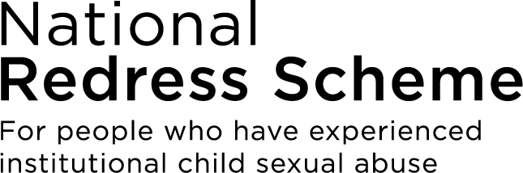

Service Charter
This is a summary version of the full Service Charter for your National Redress Scheme: Our commitments to survivors of institutional child sexual abuse. Further information is available at
www.nationalredress.gov.au/charter.

What the Charter is for
The Service Charter for your National Redress Scheme covers how the Scheme operates. It explains what you can expect when you engage with us and sets out our commitments to survivors to support each stage of your redress journey.

Our commitments to you
The following table details the improvements that are currently in progress or that are being planned for the National Redress Scheme.

Stage of redress journey | Our commitments
Finding out about the Scheme and considering your options | 1. Make information available about the Scheme when you need it or are ready to engage.  2. Ensure you can access a support service, legal advice and financial counselling to consider your options, if you want to.  3. Be clear about how we protect information and keep it private and confidential.
Making an application | 4. Make the application forms and process accessible.  5. Provide guidance about what information is important for you to include in your application for it to be assessed.  6. Make sure you can get support to make an application, if you want to.  7. Provide sufficient time for you to make an application.  8. Connect with you in a safe way once we receive your application.  9. Make sure the application process is secure and it is clear how your information will be used.
Progressing your application | 10. Make sure you know what is happening as we progress your application.  11. Make sure you can access free and independent support while you wait for a redress outcome.
Being advised of a redress outcome | 12. Provide the redress outcome to you in a safe way.  13. Make sure you have support to consider the outcome.  14. Explain the outcome clearly.  15. Make it clear how your redress is provided and the help available to you.  16. Make sure you have support to accept the outcome.  17. Make sure you know how to request a review and have support to do so  18. Provide a clear and timely response to your review.

About the National Redress Scheme
The National Redress Scheme (the Scheme) provides redress to people who experienced institutional child sexual abuse. The Scheme:

- acknowledges that many children were sexually abused in Australian institutions.
- holds institutions accountable for this abuse.
- helps people who have experienced institutional child sexual abuse gain access to counselling, a direct personal response, and a Redress payment.

Principles for how we work with you
Four principles guide the way we engage with you:

- Survivor-centered: We respect your rights and self-agency to make your own decisions.
- Supportive and safe: We support your individual needs and treat your story with care and confidentiality.
- Inclusive and accessible: We explain what things mean in simple and clear language. We make sure you can engage with us and in the process.
- Transparent and accountable: We are open and honest about what you can expect from us and whether we are meeting our commitments.

Service standards
We have service standards for the Scheme that cover:

- National Redress Scheme Contact Centre.
- Your contact with the Scheme.
- Progressing applications.
- Protecting your information.
- Making a complaint or providing feedback.

Contact us
If you have questions or need advice or support, you can contact us.
- Calling from Australia: by phone on 1800 737 377 from Australia (call charges may apply), Monday to Friday 8am to 5pm AET.
- Redress Support: A list of free, independent support services and their contact details are available at the website www.nationalredress.gov.au/support. Services can provide practical and emotional support, legal advice, and financial counselling. They can support you before, during and after you apply for redress.

