Strategic Success Measures
June 2023
Contents
Key Operating data: Redress Applications 2
1. Survivor Experience 3
1a. Application timeliness 3
1b. Survivor journey 4
1c. Advance payment 5
1d. Redress payment 6
2. Health of the Scheme 7
2a. Survivor acceptance 7
2b. Maintaining institution participation 8
2c. Quality decision making 9
3. Equity of Access 10
3a. Scheme accessibility 10
3b. Support service accessibility 12

Key Operating data: Redress Applications
As at 30 June 2023, 27,756 applications had been received by the Scheme. Of these:
- 12,758 applications were finalised (13,461 outcomes have been issued to applicants)
- Since the start of the Scheme, 12,046 payments were made totalling approximately $1.07 billion, with an average payment amount of $88,628.
- 14,043 applications were on hand being processed
  - 632 offers had been made and are awaiting an applicant’s decision
  - 1,435 applications were with institutions to provide information
  - 3,836 applications were on hold (for reasons such as at the request of the applicant, due to a non-participating institution, or difficulty in contacting the applicant)
- 8,140 applications were in progress:
- 5,648 applications were able to be actioned
- 2,492 applications were unable to be actioned (for reasons such as awaiting the applicant to contact the Scheme or awaiting more information)
- 955 applications had been withdrawn
- 484 reviews had been requested
- 1,750 advance payments had been made
- Approximately 403,900 calls had been made to the Scheme

Survivor Experience

1a. Application timeliness
At least 75% of applications that name institutions that participate in the Scheme will have a decision communicated to the applicant within 6 months of all necessary information being received by the Scheme ^{[1]}.
The following data was accurate as at 30 June 2023 and indicated that since 2020-21, the Scheme has delivered on this objective.

Figure 1a – Percentage of Outcomes Notified within 6 months of Receiving All Required Information
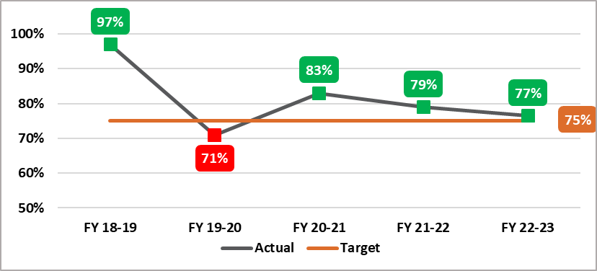
Source: National Redress Scheme, June 2023

As at 30 June 2023, the average processing time for applications was 11.8 months. This was for the period from when the Scheme first received an application until the applicant was notified of an outcome. This was a different calculation from the measure presented in Figure 1a.

Note:
[1] The metric commenced timing from the point that all necessary information was received (i.e. all information from the applicant and any institutions was received) until an outcome was delivered.

1b. The Survivor Journey
Survivor experience with the process of the Scheme, including Scheme responsiveness, degree of respectful, dignified, knowledgeable and trauma-informed interactions, ease of understanding, level of pro-activity, consistency of service quality.
In 2020, the department engaged Whereto Research to develop a trauma-informed, safe, and respectful survey to report on the survivor journey. Applicants were invited to opt-in to receiving the survey through their letter of offer. The survey collected information about applicants’ experiences with the Scheme.
The number of people who responded to the survey was relatively small in proportion to all those who received an outcome. The survey responses received provided valuable information to help the Scheme identify trends over time and how survivors felt about their interactions with the Scheme but these responses may not be representative of the whole applicant population.
Results from the survey report delivered to the department in November 2022 included:

- 1,594 people accepted an offer of redress and were invited to opt-in
- 562 requested a survey pack
- 92 (16.4%) of those who requested a survey pack completed and returned a paper, online or telephone survey

Key Highlights:
- 82% of respondents said the outcome letter was easy to understand
- 86% found staff to be helpful and respectful and 74% of respondents were satisfied with the overall quality of service from the Scheme
- 80% of respondents accepted some form of support with their application
- 74% of respondents said the time taken to make a decision on their application was ok or about right.
- 50% of respondents reported finding it easy to find out about the Scheme

Apart from the survivor survey, the Scheme received feedback from survivors and other stakeholders through other avenues, including the survivor roundtable, correspondence, and project specific consultation. The Scheme has implemented a range of improvement measures in 2021-22 including introducing advance payments, payments by instalment and the removal of the requirement for an application to include a statutory declaration.

1c. Advance Payment
The Scheme will issue ≥80% of eligible survivors with an advance payment within 7 days of receiving acceptance documentation.
The following data was accurate as at 30 June 2023.
Following legislative amendments, advance payments were introduced in October 2021. The Scheme has delivered on its target.
Figure 1c - Percentage of Advance Payments Issued within 7 Days of Receiving Acceptance Documents
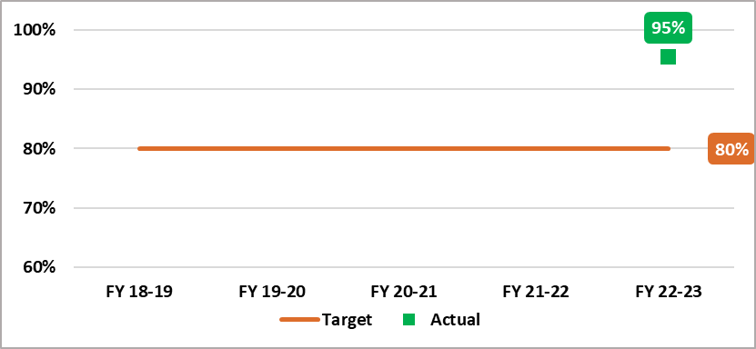
Source: National Redress Scheme, June 2023

1d. Redress Payment
The Scheme will issue ≥80% of survivors a redress payment within 14 days of receiving acceptance documentation.
The following data was accurate as at 30 June 2023. The Scheme has consistently delivered on this target.

Figure 1d – Percentage of Payments Issued within 14 Days of Receiving Acceptance Documents
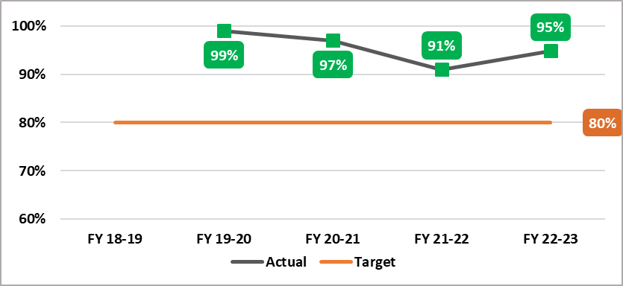
Source: National Redress Scheme, June 2023

2. Health of the Scheme

2a. Survivor acceptance
This metric measures the percentage of redress offers accepted by survivors across Direct Personal Responses and Counselling and Psychological Care services.
This data was accurate as at 30 June 2023.

- 9,211 (74%) of people who accepted an offer of redress, had also accepted the offer for Counselling and Psychological Care (CPC) services. Of these 6,124 (66%) were for referral services and 3,087 (34%) were for a lump sum payment ^{[1]}.
- 7,378 (representing 59% of applicants who responded to their offer of redress) indicated that they may like to participate in a Direct Personal Response.

Note
[1] Since January 2023 all states and territories except South Australia offered services rather than payments.

2b. Maintaining institution participation
The Scheme will engage and maintain participation, with institutions on-board to cover ≥95% of applications in progress.
This data was accurate as at 30 June 2023. Since the beginning of the Scheme, significant progress was made in this area, and the Scheme has delivered on this target since 2021-22.

Figure 2b – Percentage of On-Board Institutions Covering Applications in Progress

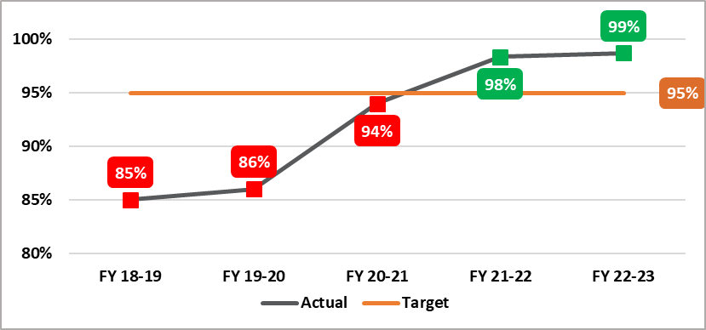

Source: National Redress Scheme, June 2023

2c. Quality Decision Making
The Scheme will maintain quality decision-making, with ≥95% of initial determinations reflecting the final outcome.
The following data was accurate as at 30 June 2023. The Scheme has consistently delivered on this target with 99% success rate. This measure of quality decision-making considered the outcomes of the review process. Less than 1% of all initial determinations were changed at the review stage.

Figure 2c – Percentage of Initial determinations reflecting the outcome.
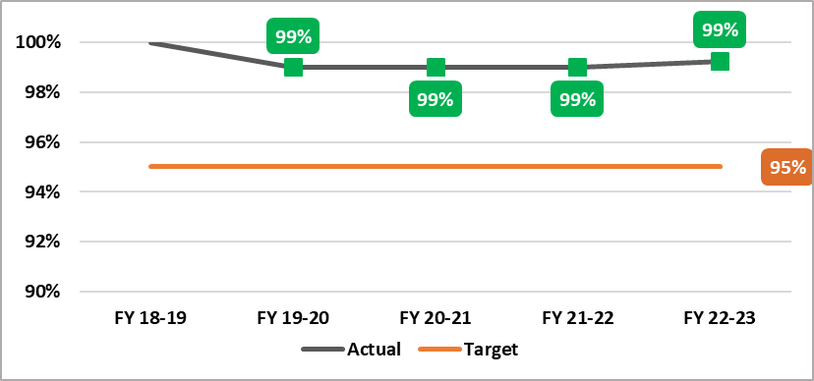

Source: National Redress Scheme, June 2023

3. Equity of Access

3a. Scheme accessibility
The number of survivors who successfully lodge an application with the Scheme each year, published according to survivor demographics, such as participation by First Nations / rural and remote / people with disability / elderly
As at 30 June 2023, the demographics of applicants over the life of the Scheme were:
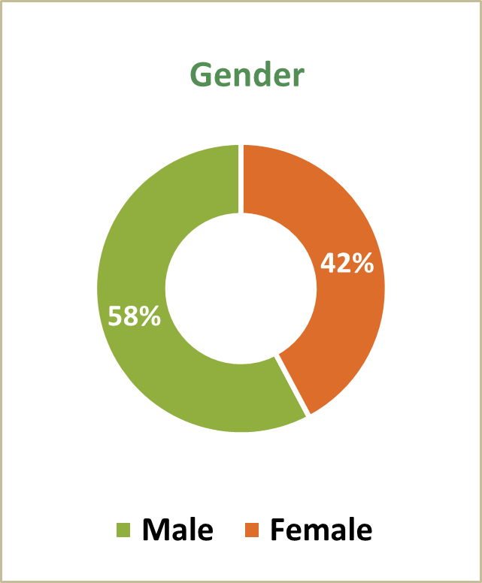 | 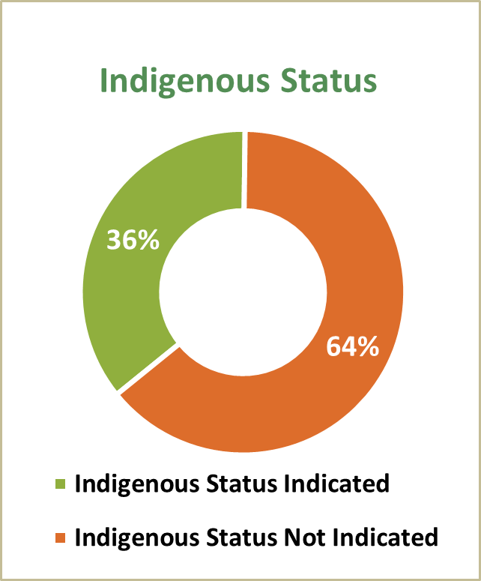
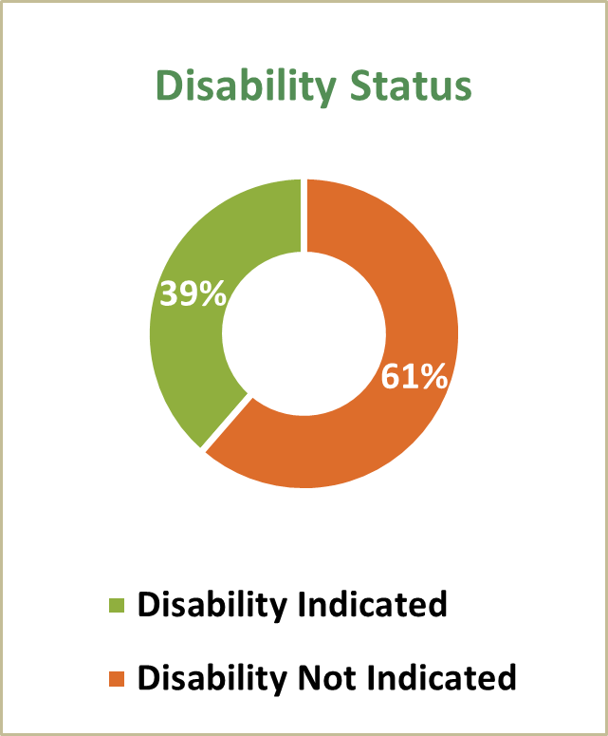 | 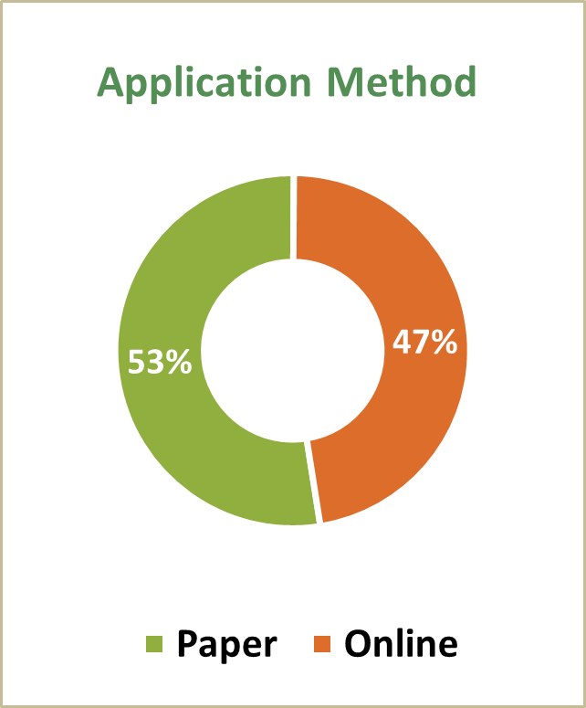

Applicant’s Residential location

National | 27,756*
ACT | 339
NSW | 5,526
NT | 271
QLD | 8,942
SA | 3,258
TAS | 1,511
VIC | 3,221
WA | 4,537
Overseas | 138
Unspecified | 13

* The National figure included overseas and unspecified numbers in addition to the jurisdiction numbers.

Scheme Accessibility: Over the life of the Scheme as at 30 June 2023

- 19% of applications received were from elderly applicants ^{[1]}
- 36% of applicants identified as First Nations
- 39% applicants self-identified as living with a disability ^{[2]}
- 42% of applicants resided in a regional or remote area ^{[3]}

Note
[1] Elderly applicants were defined as over 70 at age of application, or over 55 for First Nations applicants.
[2] Disability was not a term defined by the Scheme. Applicants may self-identify as having a disability, which included illness and age-related conditions.
[3] Remoteness was defined based on the 2016 Australian Bureau of Statistics Remoteness Areas Structure based on a measure of relative access to services.

3b. Support service accessibility
Accessibility of the Scheme’s support services to all survivor demographics, such as participation by First Nations / rural and remote / people with disability / elderly.
Redress Support Services (RSS) were specialist, trauma-informed, culturally safe, survivor centred services, which provide free, confidential, practical and emotional support before, during and after people make, or consider making, an application to the National Redress Scheme. Many Services conducted outreach to support people to apply from survivor demographics.
At 30 June 2023, there were 45 funded services, including 12 Indigenous-specific services, which ensured Aboriginal and Torres Strait Islander applicants had access to culturally safe services.

Support Service Accessibility: Over the life of the scheme as at 30 June 2023

- Approximately 15% of applicants were supported by a RSS
- Approximately 8% were supported by knowmore Legal Service
- 42% of applicants who identify as having a disability used a RSS ^{[1]}
- 27% of applicants who lived in a regional or remote location used a RSS ^{[2]}
- 32% of applicants who identified as First Nations used a RSS
- 48% of elderly applicants at application used a RSS ^{[3]}
- 32% of applicants had nominees to assist them to engage with the Scheme. These nominees were not necessarily RSS representatives – they could be an applicant’s family member, friend or lawyer.

Note
[1] Disability was not a term defined by the Scheme. Applicants may self-identify as having a disability, which included illness and age-related conditions.
[2] Remoteness was defined based on the 2016 Australian Bureau of Statistics Remoteness Areas Structure based on a measure of relative access to services.
[3] Elderly applicants were defined as over 70 at age of application, or over 55 for First Nations applicants.

